Design Your UI To Display The Temperature, Humidity

**In MIT App Inventor**

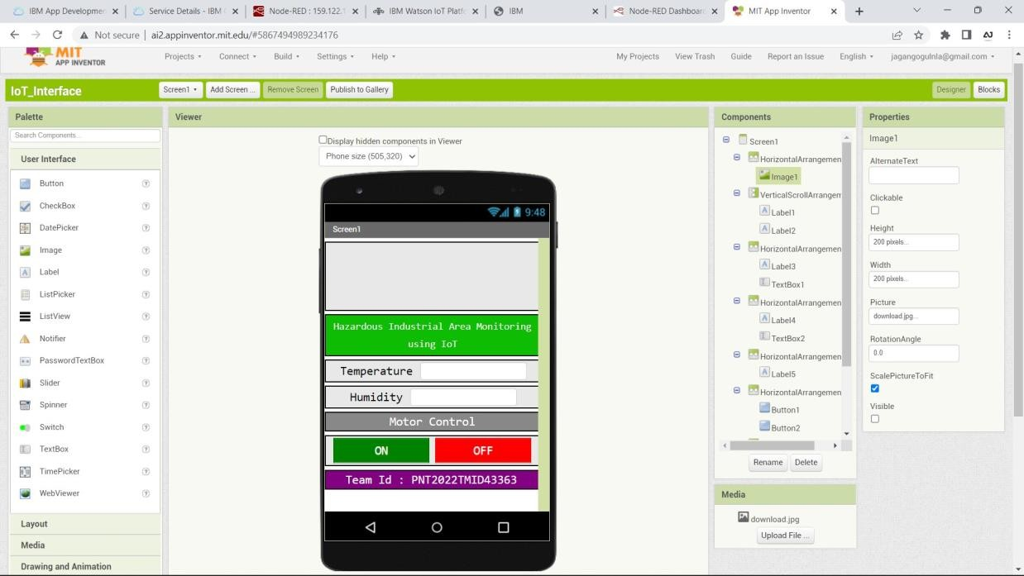

**In Mobile Phone**

